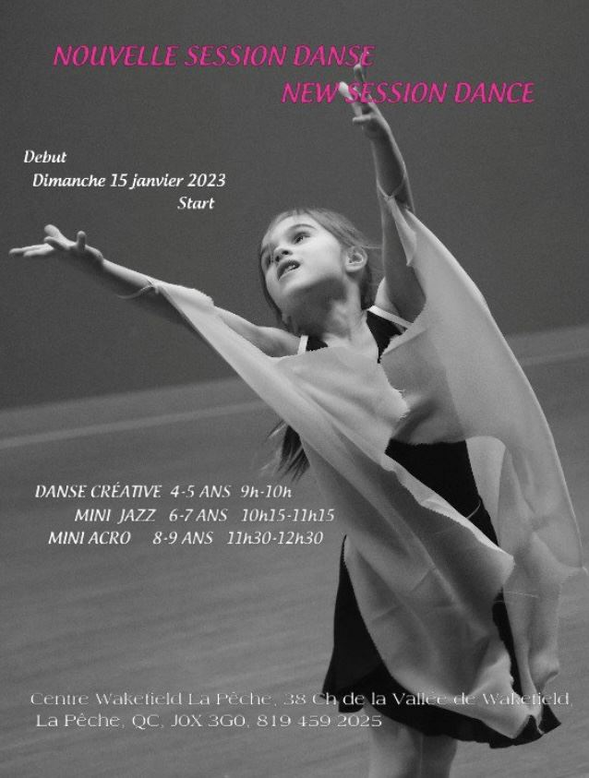
Instructor: Claudine Maltais
12 sessions for $144
Sundays 9:00 - 10:00am until April 9th
Age: 4 - 5yrs

